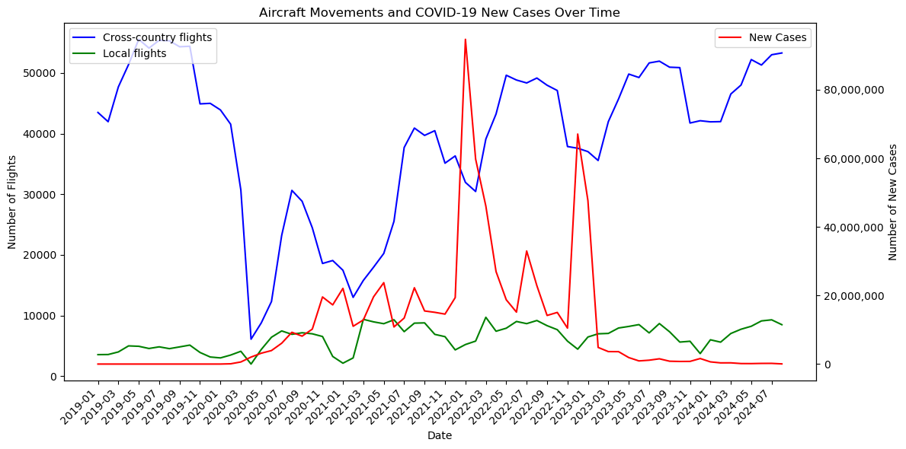

从图片中可以看出，在非疫情期间，跨国航班和国内航班都呈现夏季航班量较多，冬季航班量较少的规律。跨国航班在疫情初期受到了最严重的冲击，航班数量在2019年11月开始急剧下降，在2020年5月达到了最低点，少于10000班。但在疫情缓解后开始逐渐恢复，并在2023年左右基本回归到疫情前的数量。国内航班虽然也受到影响，但其下降幅度相对较小，恢复也较为平缓，整体数量仍保持较低水平。由图可见，全球新增感染人数与跨国航班和国际航班数的变化趋势无明显关系。可能因为虽然全球新增确诊病例数量代表了疫情的严重程度，但航班数量的变化往往是由各国政府的政策所决定。许多国家在疫情初期采取了严格的旅行限制措施，包括国际边境的关闭、航班取消等，各国政策通常是在新增病例显著上升之前即开始实施。例如，在疫情刚爆发的2020年初，虽然新增病例尚未达到顶峰，但各国已经开始实施封锁，导致航班数量急剧下降。因此可以得出结论，大流行疫情对国际和国内航班数量有显著影响，但这种影响并不直接与新增病例的变化呈现线性或同步关系。相反，这种影响更多是通过各国政府的政策、旅行限制等间接因素体现出来，而航班数量的变化往往与这些防疫措施的实施和调整密切相关。

The image shows that during non-pandemic periods, both international and domestic flights follow a seasonal pattern, with more flights in the summer and fewer in the winter. International flights were hardest hit during the early stages of the pandemic, with numbers sharply declining from November 2019 and reaching a low in May 2020, dropping below 10,000. As the pandemic eased, flights gradually recovered and returned to near pre-pandemic levels by 2023.

Domestic flights also declined, though less dramatically, and recovered more slowly, with overall numbers remaining lower. The image suggests no clear relationship between global COVID-19 cases and flight trends. This is likely because flight numbers were more influenced by government policies than the direct rise in cases. Many countries imposed strict travel restrictions, including border closures and flight cancellations, early in the pandemic, often before case numbers peaked.

In conclusion, the pandemic significantly impacted both international and domestic flight numbers. However, the impact was more closely tied to government policies and travel restrictions than to the rise in case numbers. Flight trends aligned more with the timing and adjustments of these preventive measures.